**LeanCpp**

**Chp .4**

**Introduction to development**

Steps to development:

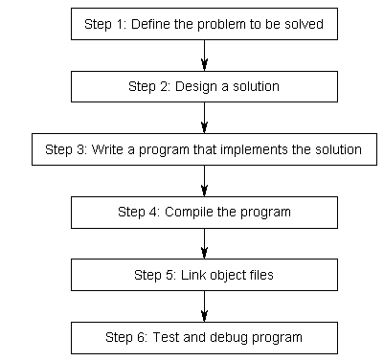

** Step 1-3 are obvious

Step 4, Compiling:

To compile programs, we use a program called a *compiler* that creates an executable file. A compiler’s job consists of 1) checking if the programmer’s code follows correct C++ syntax 2) converting every file of source code into a machine language file called an **object file** (foo.o, bar.obj)

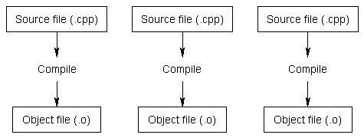

To compile with a C++ compiler, a programmer can do the following:

1. Generate the. o files then link them
   1. “g++ -c file1.cpp file2.cpp file3.cpp”
   2. “g++ -o test file1.o file2.o file3.o”
   3. “-c” means compile only 🡺 produce only object files (.o)
   4. “o” means create executable
2. Using makefiles
3. Directly creating the executable
   1. “g++ -o test file1.cpp file2.cpp file3.cpp”
4. Using **cmake**

Step 5, Linking:

Linking is known as the process of taking all the object files generated by the compiler and combining them into a single executable file. In addition to the source files made by the programmer, a linker also includes files from the C++ STL

